**Factors Influencing Prevalence of *Salmonella* in a Multi-Species Animal Facility**

*Steven Kitchens and Zheran (Rachel) Wang*

*BIOL 7250/STAT 7250*

*Auburn University, Alabama*

**Keywords:** *Salmonella*, environment, veterinary teaching hospital, prevalence,

**Introduction:**

Environmental *Salmonella* contamination can pose a risk to livestock (Ewart et al., 2001; Pandya et al., 2009). Biosecurity and risk factor analysis of *Salmonella* can help determine interventions to help control *Salmonella* on farms (Funk and Gebreyes, 2004; Fossler et al., 2005a). Veterinary teaching hospitals are good locations for collecting environmental and animal samples of *Salmonella* contamination, due to the ease of access (Pandya et al., 2009). In addition, large animals commonly found within veterinary teaching hospitals can be reservoirs for transmitting *Salmonella* to other animals (Schott et al., 2001). Preventing and controlling potential nosocomial *Salmonella* infections is an important biosecurity concern and identification of sources or factors that contribute to environmental prevalence of *Salmonella* in the environment could help to control the spread of *Salmonella* that might translate to on-farm contamination issues.

A surveillance study of a veterinary teaching hospital was conducted to better understand the dynamics of *Salmonella* in the environment within a multi-species animal facility. Veterinary teaching hospitals have many different species of animals in close proximity to one another. The environment can be a potential source and reservoir for the transmission of *Salmonella* in a veterinary hospital. Persistence of *Salmonella* in the environment has been implicated for the spread of *Salmonella* among patients in many nosocomial outbreaks of salmonellosis (Castor et al., 1989; Amavisit et al., 2001; Schott et al., 2001; M. P. Ward et al., 2005; Dunowska et al., 2007; Schaer et al., 2010). *Salmonella* is the most commonly associated agent responsible for nosocomial outbreaks among veterinary teaching hospitals (Schott et al., 2001; Kurowski et al., 2002; Cherry et al., 2004; Benedict et al., 2008; Steneroden et al., 2010). Veterinary teaching hospitals are considered an open system. Inpatients pose a great risk (more than outpatients) for infectious disease acquisition and spread. Many factors such as dietary changes, antimicrobial treatment, surgery, compromised immune systems, etc., can increase the risks of contracting and/or shedding infectious agents such as *Salmonella*. It is critical to identify factors that contribute to the contamination of the hospital environment to reduce the risk of transmission of infectious agents from inpatients to hospitalized animals and hospital personnel (Morley and Weese, 2015). Understanding an environmental “profile” that indicates areas of heightened risks can assist with targeted prevention strategies for implementation before an outbreak is detected (Burgess and Morley, 2018)

Contamination of food-animal carcasses is usually due to fecal contamination and is the principal source of human food-borne infections (Humphrey, 2000; Forshell and Wierup, 2006). Farms and their environments may become contaminated with *Salmonella* afteroutbreaks or colonization of animals, or by general contamination (Murray, 2000). Pre-harvest interventions can help in reducing *Salmonella* in feces before it has a chance to contaminate carcasses. On-farm control strategies can be successful, but identifying the routes and sources of infection of food animals is critical to develop interventions (Humphrey, 2000). Understanding *Salmonella* in livestock animals demonstrates the importance of the “One Health” concept, because livestock animals are a source for human and companion animal food products (Walther et al., 2017). We used the Auburn University College of Veterinary Medicine John Thomas Vaughan Large Animal Teaching Hospital to study *Salmonella* in the environment and to identifying factors of environmental *Salmonella* contamination in the teaching hospital.

**Objectives:**

* To analyze prevalence of *Salmonella* to identify sources or areas of environmental contamination.
* To evaluate different statistical methods to more accurately predict presence of *Salmonella.*
* The ultimate goal is to analyze prevalence of environmental *Salmonella* in order to develop future interventions.

**Materials and Methods:**

**Data:**

* **Sampling from Facilities**

Samples were collected by a variety of methods. Swab samples were performed by sterile cotton tip applicators or by gauze on structures such as floors, drains, gates, stall walls, and any other structures available for sampling. Each swab was pre-soaked in 0.1% sterile buffered peptone water (Difco) before using. Those swab samples were placed in Whirl-Pak bags (118-ml) for later analysis. Fecal samples from animals collected from the environment were placed in Whirl-Pak bags (532-ml) before being analyzed. Feed and hay samples were collected by grab sampling. All samplings were collected with clean gloves and changing gloves between samples.

* **Sampling from Pasture**

Methods used are as described with the facility samplings with the exception of fecal samples. Sterile tongue depressors were used to collect feces from five pat samples pooled in a sample cup together to represent the pasture.

* **Water Sampling**

Two methods of water collection were employed. One by using a 60cc cather-tip syringe to collect small volumes (50-60mL) of water. This was the primary method of water sampling from animal facilities and pastures which included troughs, bodies of water, and/or standing puddled water.

* **Water Sample Culturing**

Small volume water samples from animal housing troughs and standing puddled water were culture by adding 50mL of sampled water to 50mL of double concentrated buffered peptone water (2xBPW), which diluted the 2xBPW down to a concentration of 1xBPW. This sample was then cultured processed as other samples as described earlier.

* ***Salmonella* Culture and Detection**

The isolation of *Salmonella* from environmental samples method is a modified method from USDA/FSIS/OPHS Microbiology Laboratory Guidebook’s “Isolation and Identification of *Salmonella* from Meat, Poultry, Pasteurized Egg, and Catfish Products and Carcass and Environmental Sponges” (Rose, 2014). Buffered Peptone Water (BPW) was added to the Whirl-Pak bags containing sample and incubated for 24 hours at 37°C. Pre-enriched samples were divided into two enrichment broths; 0.5 ml into Tetrathionate (Difco) broth tubes (TTh) and 0.1 ml into Rappaport Vassiliadis (Difco) broth (RV) tubes. Tubes were incubated 24 hours at 41°C. Selective plating was performed by using Xylose Lysine Agar (Difco) supplemented with Tergitol 4 (Difco) (XLT4). Enrichment solutions were streaked and incubated for 24-48 hours at 37°C. Four characteristic colonies, which appear black, centered on XLT4 agar, were sub cultured onto XLT4 agar and incubated for 24-48 hours at 37°C. One characteristic colony, which appear black centered on XLT4 agar, from each of the four subcultured colonies biochemically confirmed to be *Salmonella* species based on slants of triple sugar iron (TSI) agar (BD Difco), lysine iron (LIA) agar (BD BBL), and urea agar (BD BBL). TSI, LIA, and Urea slants were inoculated in tandem with a single pick from a colony by stabbing the butts and streaking the slants in one operation and incubated for 24 hours at 37°C. A typical control on LIA should produce a purple butt with (H2S-positive) or without (H2S-negative) blackening of the media. A typical control on TSI should produce a yellow butt and red slant, with (H2S-positive) or without (H2S-negative) blackening of the media. A typical control on Urea should produce a yellowing of the media. These presumptive positive colonies were serologically confirmed with polyvalent serum A-V for *Salmonella* (Difco).

**Data Collection:**

Samples were collected over a three-year time span. Most sampling locations occurred at the AU Large Animal Teaching Hospital. As an operating veterinary hospital, not all stalls, locations, areas, and animals were accessible for the collection of samples at a given time point. All samples were collected out of convenience opposed to predetermined specific samples or samples collected randomly. Information was collected on each sample for future statistical analysis and to assist hospital sections of areas of positive *Salmonella* isolation. The information was recorded on a form designed “In-House” that specialized on characteristics thought to be of importance. Information collected on each sample was consolidated for the purpose of statistical analysis. Variables observed included recent weather, year, season, sample type, resident animal species, environment, facility, and regional location.

**Models:**

The statistical software R was used for analysis three different models was used to compare the accuracy, sensitivity, and specificity of each one.

The first model was a logistic regression model with region and years treated as random effects using the R program “glmmer”. Season, species, weather condition, and sample method were the variables included in the model. All variables had to be changed into dummy variables during analysis. A testing set was used to check the accuracy of the model. Prevalence of *Salmonella* was the dependent response (Y), S was season, C was weather condition, M was sample method, and X was species (Figure 1). After fitting the model, we calculated the odds ratios with reference level within each variable group. In this study, the reference level used for each variable was Fall (season), Feed/Hay (sample method), dry (condition), and wildlife (species). The R program “glht” was used for pairwise comparisons for different levels within categorical variables.

The second model we used was the random forest model in R to determine the variables of most importance. The variables selected to train the model are listed in Table 1. The model was then tested to determine accuracy, sensitivity, and specificity.

We used the Markov-Chain Monte-Carlo (MCMC) model as the third model to determine the posterior parameters of the model. Season, region, species, condition, and sample method were variables selected for this analysis. These variables were all converted into dummy variables. This result will help us to check the accuracy of the model and importance of the level within each variable. The accuracy, sensitivity, and specificity were determined from the model selected (Figure 2) in R.

**Results:**

The total number of samples collected over a three-year span was 887 samples. Out of 887 samples, 351 (39.57%) of samples were positive for *Salmonella* species. Reference lines used for season was Fall, species was Wildlife, weather condition was dry weather, and sample type was Feed/Hay samples. A logistic regression with region and year were treated as a random effect. Significance was found in the odds ratios and ANOVA table (Table 2). For season, significant differences were found in Summer (p=0.055) compared to the reference level Fall. For Species, significant difference was found in Bovine (p=0.010) compared to the reference level Wildlife. For weather condition, we found rain weather to significantly different (p=0.031) compared to reference level dry weather. For sample type, significant differences was found in Water (p<0.001), Drain (p<0.001), Fecal (p<0.001), and Surface (p=0.013) when compared to the reference level Feed/Hay. The ANOVA table showed that Season, Species, Weather Condition, and Sample Method were all important to the model. To compare levels within variables, a multiple comparisons of mean was done (Table 3). Based on this analysis, the variables were ranked (Table 4). The highest ranked variables were Summer season, Bovine species, Dry weather, and Water sample type. This model had an accuracy of 0.8023, sensitivity of 0.6747, and a specificity of 0.9247 (Table 6).

Data was divided into train(80% of the total) and test(20% of the total) datasets. We used the train dataset to fit the random forest model. After 10 folds, repeated 5 times, and fitting 10000 trees, the result shows that the system choose mtry=2 as the final model. Variables were ranked by most importance to the model (Graph 1). Based on this model the variables of most importance for predicting *Salmonella* prevalence was the North Auburn Beef Herd facility, the North Auburn region, Equine species, the Lab Animal Health region, and the Dairy Herd Pastures facility. Variables that had a high prevalence and had an importance greater than 50 was the Dairy Herd Pastures facility, Pastures/Outdoor environments, the McClary Dairy Parlor, and the McClary Dairy Barn. A ROC curve was used to determine the best threshold value that could give a better prediction, which the best threshold value was 0.561. The random forest model had an accuracy of 0.8192, sensitivity of 0.8429, and a specificity of 0.8037 (Table 6).

MCMC analysis (Table 1) variables of significance were rain weather condition, surface samples, drain samples, fecal samples, water samples, summer season, dairy region, food animal region, and bovine species. Table 5 shows the parameter value of the variables and the 95% Confidence Interval (CI) of each parameter. Parameters that don’t have value zero included in the 95% CI was chosen for the final model from MCMC. These variables were included in the MCMC model and the model was tested. This model had an accuracy of 0.7910, sensitivity of 0.6585, and a specificity of 0.9053 (Table 6).

**Discussion:**

The AUCVM J.T. Vaughan Teaching Hospital**,** like many other small and large animal veterinary teaching hospitals**,** has substantial environmental contamination of *Salmonella* (Schott et al., 2001; Morley, 2002; Cherry et al., 2004; Benedict et al., 2008; Steneroden et al., 2010). This study differs from other studies of *Salmonella* in veterinary teaching hospitals in that it was performed in the absence of an outbreak of clinical disease in university or client animals. We also examined the prevalence of *Salmonella* over a three-year time span and analyzed factors that may contribute to contamination of facilities. This surveillance study of *Salmonella* at a veterinary teaching hospital has looked at prevalence for a longer a period than the majority of published studies. We found similar results to previous studies, which the duration of this current study strengthens findings by previous studies. This study was originally designed to serve as a model for environmental prevalence studies of *Salmonella* on how to utilize epidemiological and biostatistical methods to determine factors that may contribute to environmental contamination of *Salmonella* in a multi-species animal facility.

The overall prevalence of *Salmonella* positive environmental samples at the J.T. Vaughan Teaching Hospital (excluding samples from Animal Health and Research Pastures and the North Auburn off-site beef herd) was 52.77% (n=650). This prevalence appears to be high compared to environmental *Salmonella* prevalence at other veterinary teaching hospitals. Stenerden et al (2010) reported that 22.9% of environmental samples collected at the James L. Voss Veterinary Teaching Hospital at Colorado State University were positive for *Salmonella* with 14.2% of samples containing the outbreak strain, which indicated widespread environmental contamination (Steneroden et al., 2010). An outbreak study at Cornell University found that 0.5% of environmental samples was positive for the outbreak strain (Schott et al., 2001; Cummings et al., 2014). A separate outbreak investigation at Michigan State University found 1.24% of environmental samples cultured and 12% of environmental samples PCR tested for the outbreak strain were positive during facility cleaning and disinfection (Schott et al., 2001). At the New Bolton Center at the University of Pennsylvania School of Veterinary Medicine, 3.3% of environmental samples were positive for *Salmonella* prior to the outbreak. During an outbreak of *Salmonella* Newport within the large animal veterinary teaching hospital, 30% of environmental samples were positive for *Salmonella* Newport which indicated widespread contamination (Schaer et al., 2010). Comparing the prevalence found at our veterinary teaching hospital to these other veterinary teaching hospitals with environmental contamination issues, it could be concluded that there is widespread contamination of *Salmonella* at the J.T. Vaughan Teaching Hospital at Auburn University.

The sections of highest prevalence (Graph 2) in our study were the dairy barns/pastures as well as the food animal barns, which had 71.7% and 60.8% positive *Salmonella* prevalence, respectively. Random forest ranked the two dairy facilities and the dairy pastures as important variables for predicting the presence of *Salmonella* (Graph 1)*.* This is further strengthened by the MCMC analysis have the dairy barns/pastures and the food animal barns as variables of significance. Bovine species is the primary patients and resident animals of these facilities and had the highest prevalence of the different species observed (Graph 3). The high level of prevalence is not surprising because individuals in these units work within both units. It could be presumed that something as simple as individuals moving between these two facilities may be a source of spread of the *Salmonella*. There are currently no footbaths or any other barriers in place to prevent movement of infectious disease agents among the facilities, which may increase the likelihood of individuals moving pathogens from one area to another. The sharp decrease in prevalence between food animal barns and the equine barns may be attributed to the footbaths located at the front and rear of the equine barns and that individuals working in the equine barns do not work in the food animal or dairy barns.

We found that environmental prevalence of *Salmonella* was not statistically different (*p* > 0.05) between Summer, Spring, and Winter (Table 3 and Graph 4), but odds ratios (Table 2) determined that the Summer season was associated with an increased probability of isolation of *Salmonella* compared to the Fall season. This finding is similar to previous studies in that prevalence of *Salmonella* among dairy cattle is higher in the Spring, Summer, and Fall seasons with peaks typically during Summer months (Fossler et al., 2005b; Pangloli et al., 2008; Cummings et al., 2009). Cummings et al (2009c) found Fall to be significantly higher for shedding of *Salmonella* in calves admitted to a veterinary teaching hospital (Cummings et al., 2009c). Pangloli et al (2008) found *Salmonella* to have a high prevalence (> 40%) in environmental samples in all seasons with the exception of winter (Pangloli et al., 2008). A study of cattle and environmental sampling factors on *Salmonella* among dairies found that Fall, Spring, and Summer seasons were factors associated with *Salmonella* shedding in cattle (Fossler et al., 2005b). We found an increased odds of isolating *Salmonella* during dry weather when compared to recent rainfall, which is different from previous studies that found prevalence of *Salmonella* to increase with rainfall (Polo et al., 1999; Haley et al., 2009; Jacobsen and Bech, 2012)

It is not surprising that water (54.3%), drain (47.7%), and fecal (40.8%) sources had the highest prevalence among the environment (Graph 5). Fecal samples and surface (37.2%) were not significantly different (Table 3), but feed and hay (16.4%) samples were significantly different than all other sample types. It was not surprising to find water sources with the highest prevalence of *Salmonella* because water can be a source for dissemination of enteric pathogens to livestock (Doyle and Erickson, 2006). *Salmonella* was also highly recovered from drain samples, similar to the findings of others who isolated *Salmonella* from floor drains (Castor et al., 1989; Schott et al., 2001; Michael P Ward et al., 2005). Others have found that drain surfaces were the most common site of *Salmonella* recovery with a prevalence of 7.3% (Pandya et al., 2009); we also found that the highest prevalence of *Salmonella* was recovered from water and drain sources, but drain samples at a much higher level (47.7%) compared to previous studies. The multiple comparisons of means showed that water, drain, and fecal samples are the most important type of samples to collect when actively surveying for environmental *Salmonella*.

The three different models had differed slightly among one another, but overall indicated areas of importance being bovine species, summer season, water samples, drain samples, fecal samples, food animal varns, and the dairy barns/pastures (Tables 2, 3, 4, 5 and Graph 1). The random forest model was the most accurate and most sensitive of the three models (Table 6). Random forest is a non-parametric method, and the variables are ranked according to how well they predict the isolation and non-isolation of *Salmonella* species. This can be useful in determining areas at risk in order to focus infection control surveillance. The downside is that this does not give information on sources of contamination if an existing outbreak or widespread contamination is occurring. The MCMC model provided more narrowed information to assist with identification potential sources of contamination.

Environmental surveillance programs for *Salmonella* have shown a correlation between environmental contamination and infection in animals (Ewart et al., 2001; Burgess et al., 2004; Dunowska et al., 2007; Schaer et al., 2010; Traverse and Aceto, 2015). Identifying the source of environmental contamination or factors associated with contamination is critical for developing interventions to prevent infections in animals. Hopefully interventions that interrupt transmission from the environment to animals also help prevent movement of zoonotic agents into the food chain at the pre-harvest level.

Our results are similar to other studies which suggest that individuals working within the food animal section (dairy barns/pastures and food animal barns) should be more aware of potential risks of nosocomial and zoonotic infections by *Salmonella* and implement intervention strategies to prevent transmission. The food animal section workers should have training in good hygiene, biosecurity, and disease control programs. A good resource which describes the general principles of an infectious disease control program in large animal veterinary hospitals is available (Smith et al., 2004). Currently at the large animal teaching hospital, minimal standard operating procedures exist for the monitoring and cleaning practices to contain or prevent *Salmonella* contamination.

There is no “one size fits all” infection control and prevention program. An appropriate infection control plan should be tailored to a facility’s unique operational limits (Dargatz and Traub-Dargatz, 2004; Stockton et al., 2006; Burgess and Morley, 2015). This study found *Salmonella* associated with dairy barns/pastures and the dairy herd, but this may not be same situation at all institutions. *Salmonella* has been documented to move from equine facilities to non-equine patients at Cornell University and the University of Pennsylvania veterinary teaching hospitals (Schaer et al., 2010; Cummings et al., 2014). Analysis of the AUCVM teaching hospital indicates critical control points involving our on-site dairy herd that are unique to the AUCVM. The AUCVM is fortunate to have a model dairy to train students and analysis from this study should help individuals within these areas to remain vigilant in the prevention of transmission of infectious agents such as *Salmonella*.

**References:**

Amavisit, P., Markham, P.F., Lightfoot, D., Whithear, K.G., Browning, G.F., 2001. Molecular Epidemiology of *Salmonella* Heidelberg in an Equine Hospital. Vet. Microbiol. 80, 85–98. doi:10.1016/S0378-1135(00)00373-4

Benedict, K.M., Morley, P.S., Metre, D.C. Van, 2008. Characteristics of Biosecurity and Infection Control Programs at Veterinary Teaching Hospitals. J. Am. Vet. Med. Assoc. 233, 767–773.

Burgess, B. a, Morley, P.S., Hyatt, D.R., 2004. Environmental Surveillance for *Salmonella* enterica in a Veterinary Teaching Hospital. J. Am. Vet. Med. Assoc. 225, 1344–1348. doi:10.2460/javma.2004.225.1344

Burgess, B.A., Morley, P.S., 2018. Risk Factors for Veterinary Hospital Environmental Eontamination with *Salmonella* enterica. Epidemiol. Infect. 1–11.

Burgess, B.A., Morley, P.S., 2015. Veterinary Hospital Surveillance Systems. Vet. Clin. North Am. - Small Anim. Pract. 45, 235–242. doi:10.1016/j.cvsm.2014.11.002

Castor, M., L.Wooley, R.E., Shotts, E.B., Brown, J., Payeur, J.B., 1989. Characteristics of *Salmonella* Isolated From an Outbreak of Equine Salmonellosis in a Veterinary Teaching Hospital. J. Equine Vet. Sci. 9, 236–241.

Cherry, B., Burns, A., Johnson, G.S., Pfeiffer, H., Dumas, N., Barrett, D., Mcdonough, P.L., Eidson, M., 2004. *Salmonella* Typhimurium Outbreak Associated with Veterinary Clinic. Emerg. Infect. Dis. 10, 2249–2251.

Cummings, K.J., Divers, T.J., Mcdonough, P.L., Warnick, L.D., 2009. Fecal Shedding of *Salmonella* spp Among Cattle Admitted to a Veterinary Teaching Hospital. J. Am. Vet. Med. Assoc. 234, 1578–1585.

Cummings, K.J., Rodriguez-Rivera, L.D., Mitchell, K.J., Hoelzer, K., Wiedmann, M., McDonough, P.L., Altier, C., Warnick, L.D., Perkins, G. a., 2014. *Salmonella* *enterica* Serovar Oranienburg Outbreak in a Veterinary Medical Teaching Hospital with Evidence of Nosocomial and On-Farm Transmission. Vector-Borne Zoonotic Dis. 14, 496–502. doi:10.1089/vbz.2013.1467

Dargatz, D. a, Traub-Dargatz, J.L., 2004. Multidrug-Resistant *Salmonella* and Nosocomial Infections. Vet. Clin. North Am. Equine Pract. 20, 587–600. doi:10.1016/j.cveq.2004.07.008

Doyle, M.P., Erickson, M.C., 2006. Reducing the Carriage of Foodborne Pathogens in Livestock and Poultry. Poult. Sci. 85, 960–973.

Dunowska, M., Morley, P.S., Traub-Dargatz, J.L., Davis, M. a, Patterson, G., Frye, J.G., Hyatt, D.R., Dargatz, D. a, 2007. Comparison of *Salmonella* *enterica* serotype Infantis Isolates from a Veterinary Teaching Hospital. J. Ap 102, 1527–1536. doi:10.1111/j.1365-2672.2006.03198.x

Ewart, S.L., Schott, H.C., Robison, R.L., Dwyer, R.M., Eberhart, S.W., Walker, R.D., 2001. Identification of Sources of *Salmonella* Organisms in a Veterinary Teaching Hospital and Evaluation of the Effects of Disinfectants on Detection of *Salmonella* Organisms on Surface Materials. J. Am. Vet. Med. Assoc. 218, 1145–1151. doi:10.2460/javma.2001.218.1145

Forshell, L.P., Wierup, M., 2006. *Salmonella* Contamination: A Significant Challenge To The Global Marketing of Animal Food Products. Rev. Sci. Tech. 25, 541–554.

Fossler, C.P., Wells, S.J., Kaneene, J.B., Ruegg, P.L., Warnick, L.D., Bender, J.B., Eberly, L.E., Godden, S.M., Halbert, L.W., 2005a. Herd-level factors associated with isolation of *Salmonella* in a multi-state study of conventional and organic dairy farms II. *Salmonella* shedding in calves. Prev. Vet. Med. 70, 279–91. doi:10.1016/j.prevetmed.2005.04.002

Fossler, C.P., Wells, S.J., Kaneene, J.B., Ruegg, P.L., Warnick, L.D., Bender, J.B., Eberly, L.E., Godden, S.M., Halbert, L.W., 2005b. Herd-level Factors Associated with Isolation of *Salmonella* in a Multi-State Study of Conventional and Organic Dairy Farms I. *Salmonella* Shedding in Cows. Prev. Vet. Med. 70, 257–77. doi:10.1016/j.prevetmed.2005.04.003

Funk, J., Gebreyes, W.A., 2004. Risk Factors Associated with *Salmonella* Prevalence on Swine Farms. J. Swine Heal. Prod. 12, 246–251.

Haley, B.J., Cole, D.J., Lipp, E.K., 2009. Distribution, Diversity, and Seasonality of Waterborne *Salmonella*e in a Rural Watershed. Appl. Environ. Microbiol. 75, 1248–1255. doi:10.1128/AEM.01648-08

Humphrey, T., 2000. Public-health Aspects of *Salmonella* Infection, in: Wray, C., Wray, A. (Eds.), *Salmonella* in Domestic Animals. CABI Publishing, New York, NY, pp. 245–264.

Jacobsen, C.S., Bech, T.B., 2012. Soil Survival of *Salmonella* and Transfer to Freshwater and Fresh Produce. Food Res. Int. 45, 557–566. doi:10.1016/j.foodres.2011.07.026

Kurowski, P.B., Traub-Dargatz, J.L., Morley, P.S., Gentry-Weeks, C.R., 2002. Detection of *Salmonella* spp in Fecal Specimens by Use of Real-Time Polymerase Chain Reaction Assay. Am. J. Vet. Res. 63, 1265–1268.

Morley, P.S., 2002. Biosecurity of Veterinary Practices. Vet. Clin. North Am. Food Anim. Pract. 18, 133–155. doi:10.1016/S0749-0720(02)00009-9

Morley, P.S., Weese, J.S., 2015. Biosecurity and Infection Control for Large Animal Practices, in: Smith, B.P. (Ed.), Large Animal Internal Medicine. Elsevier, New York, NY, pp. 1407–1431.

Murray, C.J., 2000. Environmental Aspects of *Salmonella*, in: *Salmonella* in Domestic Animals. pp. 265–283.

Pandya, M., Wittum, T., Tadesse, D.A., Gebreyes, W., Hoet, A., 2009. Environmental *Salmonella* Surveillance in The Ohio State University Veterinary Teaching Hospital. Vector-Borne Zoonotic Dis. 9, 649–654. doi:10.1089/vbz.2008.0120

Pangloli, P., Dje, Y., Ahmed, O., Doane, C.A., Oliver, S.P., Draughon, F.A., 2008. Seasonal Incidence and Molecular Characterization of *Salmonella* from Dairy Cows, Calves, and Farm Environment. Foodborne Pathog. Dis. 5, 87–96. doi:10.1089/fpd.2008.0048

Polo, F., Figueras, M.J., Inza, I., Sala, J., Fleisher, J.M., Guarro, J., 1999. Prevalence of *Salmonella* Serotypes in Environmental Waters and Their Relationships with Indicator Organisms. Antonie Van Leeuwenhoek 75, 285–92. doi:10.1023/A:1001817305779

Schaer, B.L.L.D., Aceto, H., Rankin, S.C.C., 2010. Outbreak of Salmonellosis Caused by *Salmonella* enterica Serovar Newport MDR-AmpC in a Large Animal Veterinary Teaching Hospital. J. Vet. Intern. Med. 24, 1138–1146.

Schott, H.C., Ewart, S.L., Walker, R.D., Dwyer, R.M., Dietrich, S., Eberhart, S.W., Kusey, J., Stick, J. a, Derksen, F.J., 2001. An Outbreak of Salmonellosis Among Horses at a Veterinary Teaching Hospital. J. Am. Vet. Med. Assoc. 218, 1152–1159. doi:10.2460/javma.2001.218.1152

Smith, B.P., House, J.K., Magdesian, K.G., Jang, S.S., Cabral, R.L., Madigan, J.E., Herthel, W.E., 2004. Principles of an Infectious Disease Control Program for Preventing Nosocomial Gastrointestinal and Respiratory Tract Diseases in Large Animal Veterinary hospitals. J. Am. Vet. Med. Assoc. 225, 1186–1195. doi:10.2460/javma.2004.225.1186

Steneroden, K.K., Metre, D.C. Van, Jackson, C., Morley, P.S., 2010. Detection and Control of a Nosocomial Outbreak Caused by *Salmonella* Newport at a Large Animal Hospital. J. Vet. Intern. Med. 24, 606–616.

Stockton, K. a, Morley, P.S., Hyatt, D.R., Burgess, B. a, Patterson, G., Dunowska, M., Lee, D.E., 2006. Evaluation of the Effects of Footwear Hygiene Protocols on Nonspecific Bacterial Contamination of Floor Surfaces in an Equine Hospital. J. Am. Vet. Med. Assoc. 228, 1068–1073. doi:10.2460/javma.228.7.1068

Traverse, M., Aceto, H., 2015. Environmental Cleaning and Disinfection. Vet. Clin. North Am. - Small Anim. Pract. 45, 299–330. doi:10.1016/j.cvsm.2014.11.011

Walther, B., Tedin, K., Lübke-Becker, A., 2017. Multidrug-Resistant Opportunistic Pathogens Challenging Veterinary Infection Control. Vet. Microbiol. 200, 71–78. doi:10.1016/j.vetmic.2016.05.017

Ward, M.P., Alinovi, C. a., Couetil, L.L., Wu, C.C., 2005. Evaluation of a PCR to Detect *Salmonella* in Fecal Samples of Horses Admitted to a Veterinary Teaching Hospital. J. Vet. Diagnostic Investig. 17, 118–123. doi:10.1177/104063870501700204

Ward, M.P., Brady, T.H., Coue, L.L., Liljebjelke, K., Maurer, J.J., Ching, C., 2005. Investigation and Control of an Outbreak of Salmonellosis Caused by Multidrug-Resistant *Salmonella* Typhimurium in a Population of Hospitalized Horses. Vet. Microbiol. 107, 233–240. doi:10.1016/j.vetmic.2005.01.019

**Figures, Tables, and Graphs:**

$$\ln\left(\frac{p\left(y=1\right)}{1-p}\right)= β_{0}+ β_{1}S+β_{2}C+ β_{3}M+ β_{4}X+Random Effects$$

**Figure 1: Logistic Regression Model with Random Effects.** Prevalence of *Salmonella* was the dependent response (Y), S = season, C = weather condition, M =sample method, and X = species

$$\ln\left(\frac{p\left(y=1\right)}{1-p}\right)= β_{0}+ β_{1}summer+β_{2}dairy+ β_{3}food.animal+ β_{4}bovine+β_{5}recent.rainfall+ β_{6}surface.sample+ β_{7}drain.sample + β_{8}fecal.sample + β_{9}water.sample$$

**Figure 2: MCMC Test Model**

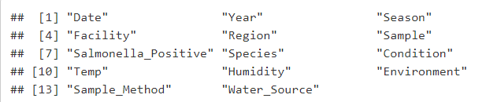

**Table 1: Variables Selected to Train Model in Random Forest**



**Table 2: Logistic Regression with Random Effect: Odds Ratio**

|  |  |  |  |
| --- | --- | --- | --- |
|  | **Group** | | |
| **Species** |  | | |
| Bovine | A |  |  |
| Equine | A | B |  |
| Wildlife |  | B |  |
| Domestic Large Animals |  | B |  |
|  |  |  |  |
| **Season** |  |  |  |
| Summer | A |  |  |
| Spring | A | B |  |
| Winter | A | B |  |
| Fall |  | B |  |
|  |  |  |  |
| **Sample Type** |  |  |  |
| Water | A |  |  |
| Drain | A |  |  |
| Fecal | A | B |  |
| Surface |  | B |  |
| Feed/Hay |  |  | C |

**Table 3: Multiple Comparisons of Means: Tukey Contrasts**

|  |  |  |  |
| --- | --- | --- | --- |
| **Season** | **Species** | **Weather Condition** | **Sample Type** |
| **Summer** | **Bovine** | **Dry** | **Water** |
| **Spring** | **Equine** | **Rain** | **Drain** |
| **Winter** | **Wildlife** |  | **Fecal** |
| **Fall** | **Domestic Large Animal** |  | **Surface** |
|  |  |  | **Feed/Hay** |

**Table 4: Rankings of Variables Based on Multiple Comparisons of Means: Tukey Contrasts**

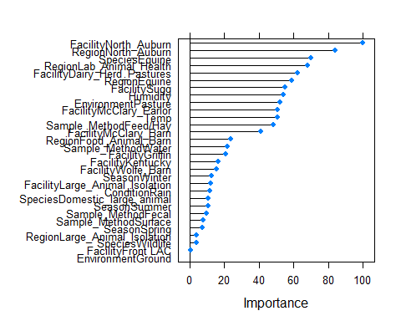

**Graph 1: Random Forests: Variables of Importance**

|  |  |  |  |  |  |  |
| --- | --- | --- | --- | --- | --- | --- |
|  | Mean | 2.50% | 25% | 50% | 75% | 97.50% |
| b0 | -7.41 | -10.57 | -8.38 | -7.34 | -6.33 | -4.64 |
| Spring | 0.54 | -0.09 | 0.33 | 0.54 | 0.75 | 1.14 |
| Domestic Large Animal Species | 0.05 | -1.27 | -0.42 | 0.05 | 0.51 | 1.33 |
| Equine Barns | 2.15 | -0.40 | 1.09 | 2.05 | 3.08 | 5.40 |
| Rain Condition | -0.60 | -1.07 | -0.76 | -0.60 | -0.45 | -0.15 |
| Surface Sample | 1.03 | 0.24 | 0.76 | 1.03 | 1.30 | 1.81 |
| Drain Sample | 2.56 | 1.75 | 2.28 | 2.56 | 2.84 | 3.39 |
| Fecal Sample | 2.19 | 1.49 | 1.94 | 2.18 | 2.44 | 2.93 |
| Water Sample | 2.85 | 2.05 | 2.57 | 2.85 | 3.13 | 3.65 |
| Winter | 0.13 | -0.50 | -0.08 | 0.13 | 0.35 | 0.76 |
| Summer | 0.67 | 0.07 | 0.47 | 0.67 | 0.88 | 1.27 |
| Dairy | 5.56 | 2.96 | 4.60 | 5.48 | 6.53 | 8.39 |
| Lab Animal Health | 0.84 | -1.98 | -0.17 | 0.80 | 1.84 | 3.87 |
| North Auburn | -0.20 | -3.08 | -1.24 | -0.25 | 0.82 | 2.91 |
| Food Animal Barns | 4.33 | 1.72 | 3.36 | 4.24 | 5.31 | 7.14 |
| Equine Species | 1.15 | -1.19 | 0.16 | 1.13 | 2.03 | 3.88 |
| Bovine Species | 1.52 | 0.36 | 1.13 | 1.53 | 1.93 | 2.64 |

**Table 5: MCMC Empirical Mean and Quantiles**

|  |  |  |  |
| --- | --- | --- | --- |
| **Model Type** | **Accuracy** | **Sensitivity** | **Specificity** |
| **Logistic Regression** | 0.8023 | 0.6747 | 0.9247 |
| **Random Forest** | 0.8192 | 0.8429 | 0.8037 |
| **MCMC** | 0.7910 | 0.6585 | 0.9053 |

**Table 6: Accuracy, Sensitivity, and Specificity for Each Model.**

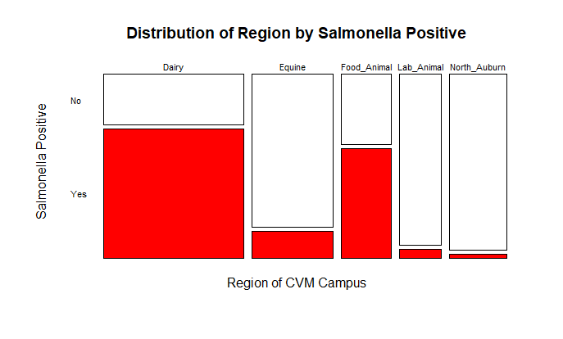

**Graph 2: Distribution of Region by *Salmonella* Prevalence**

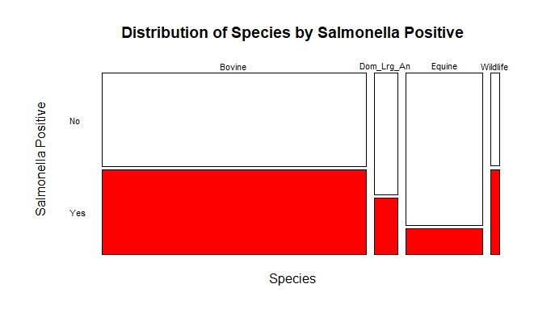

**Graph 3: Distribution of Species by *Salmonella* Prevalence**

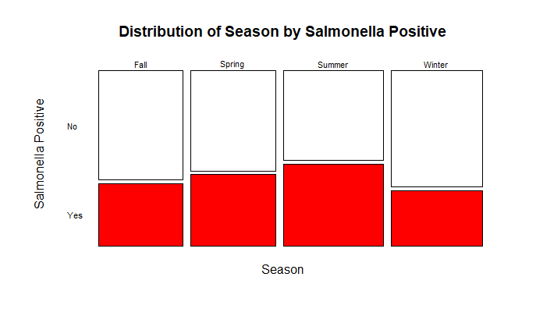

**Graph 4: Distribution of Season by *Salmonella* Prevalence**

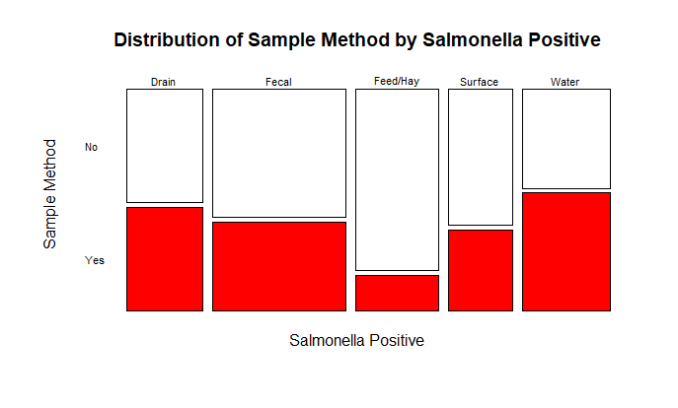

**Graph 5: Distribution of Sample Method by *Salmonella* Prevalence**